Sunday | Monday | Tuesday | Wednesday |  | Thursday | Friday | Saturday
 |  |  |  | 1 | 2  Groundhog Day | 3 | 4
5 | 6 | 7 |  | 8 | 9 | 10 | 11
12 | 13 | Valentine’s Day |  | 15 | 16 | 17 | 18
19 | 20  Presidents’ Day | 21  Mardi Gras |  | 22  Ash Wednesday | 23 | 24 | 25
26 | 27 | 28

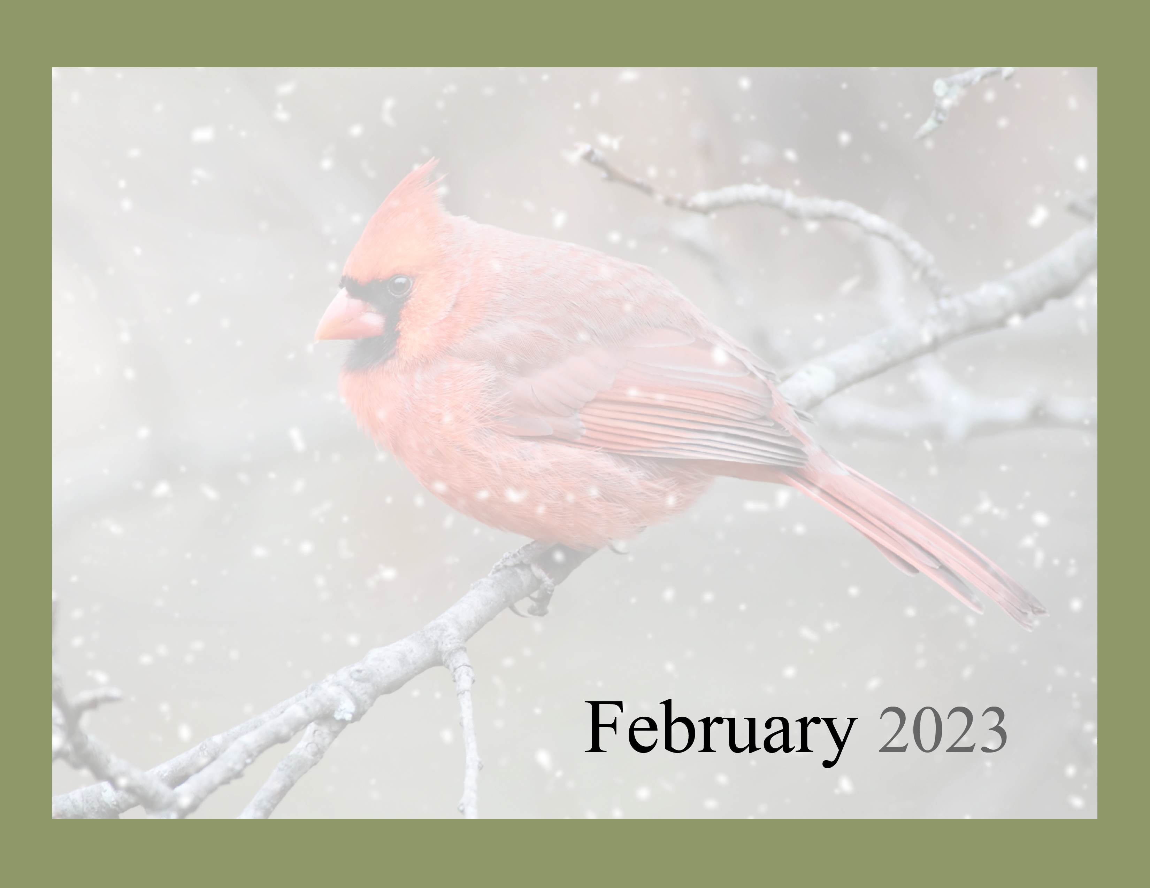  “The most wasted of all days is one without laughter.”  --e.e.cummings |  |  | Daily Chronicles  10:00 Silvercises  11:45 Table Talk  2:00 Let’s Make Heart Wreaths! | Daily Chronicles  9:15 Open Exercises  11:45 Table Talk  2:30 Chef Kevin  4:30 Living Waters  Mary Lou San. B;day | Daily Chronicles  10:00 Bible Study  11:45 Table Talk  2:00 Valentine Cards | Daily Chronicles
Daily Chronicles  10:00 Montrose Methodist Choir  5:00 Bernice’s Piano Hymns | Daily Chronicles  9:15 Open Exercises  11:00 Proenneke Book Club finale  11:45 Table Talk  2:00 National Frozen Yogurt Day | Daily Chronicles  9:15 Open Exercises  11:00 Black History Moments  11:45 Table Talk  2:00 You Be the Judge | Daily Chronicles  10:00 Silvercises  11:45 Table Talk  2:00 The Humble Potato in a Pan: Pierogies | Daily Chronicles  9:15 Open Exercises  11:45 Table Talk  2:00 High School Sweetheart Happy Hour | Daily Chronicles  10:00 Bible Study  11:45 Table Talk  2:00 M&M Butterfly Craft  Rita Gerhardt B’day | Daily Chronicles
Daily Chronicles  5:30 Super Bowl Kickoff Party  Nellie M. B;day | Daily Chronicles  9:15 Open Exercises  11:45 Table Talk  2:00 Bingo  Ashley Franklin B;day  Emily Smith B’day | 14  Daily Chronicles  9:15 Open Exercises  11:45 Table Talk  2:15 Valentine Party | Daily Chronicles  10:00 Silvercises  11:00 Black History Moments  11:45 Table Talk  2:00 Craft Stick Quilt Block Craft | Daily Chronicles  9:15 Open Exercises  11:00 Word Games  11:45 Table Talk  2:00 Studebaker Happy Hour | Daily Chronicles  10:00 Bible Study  11:45 Table Talk  2:00 Cupcakes | Daily Chronicles
Daily Chronicles  1:00 Daytona 500 Party  5:00 Bernice’s Piano Hymns  Judy J. B;day | Daily Chronicles  9:15 Open Exercises  11:00 Presidents Day Trivia  11:45 Table Talk  2:00 Noisy Neighbors Band | Daily Chronicles  9:15 Open Exercises  11:00 Resident Council  11:45 Table Talk  2:00 Silver Steppers | Daily Chronicles  10:00 Silvercises  11:00 Books & Birds  11:45 Table Talk  2:00 Coloring Club | Daily Chronicles  9:15 Open Exercises  11:00 Black History Moments  11:45 Table Talk  2:00 February Dips Birthday Party  Mary Sym. B;day | Daily Chronicles  10:00 Bible Study  11:45 Table Talk  2:00 Sunshine Sisters | Daily Chronicles  Lola L. B;day
Daily Chronicles  5:00 Bernice’s Piano Hymns | Daily Chronicles  9:15 Open Exercises  11:00 Vintage Voyagers  11:45 Table Talk  2:00 Bingo | Daily Chronicles  9:15 Open Exercises  11:45 Table Talk  2:00 Over the Hill Gang music  Phil F. B;day* | Montrose Health Center Activities

